Sprint 2 – Accuracy System Design Document

November 18, 2021

Kevin/Jodan/Jack

Table of Contents:
1. Executive Summary 2
1.1 Project Overview 2
1.2 Purpose and Scope of this Specification 2
2. Product/Service Description 2
2.1 Product Context 2
2.2 User Characteristics 2
2.3 Assumptions 2
2.4 Constraints 3
2.5 Dependencies 3
3. Requirements 3
3.1 Functional Requirements 3
3.2 Security 4
3.2.1 Protection 4
3.2.2 Authorization and Authentication 4
3.3 Portability 4
4. Requirements Confirmation/Stakeholder sign-off 4
5. System Design 4
5.1 Algorithm 5
5.2 System Flow 5
5.3 Software 5
5.4 Hardware 6
5.5 Test Plan 6
5.6 Task List/Gantt Chart 7
5.7 Staffing Plan 7

Executive Summary

Project Overview
This second sprint of endurance will make our robot successfully run the Figure 8 course five times and stay in the path provided upon finishing robot will speak “I am the winner” and flash multi colored lights for five second. The intended audience for this project is for the professor, fellow classmates and possibly some online viewers via online video to watch our robot perform the first sprint of endurance.

Purpose and Scope of this Specification
The purpose and the scope of this specification is to make the robot start from the center of the course and go in a Figure 8 course five times following the blue tape on the floor and then flashing lights and speaking when completed robot must return to its starting location.
In scope
This document addresses requirements related to phase 3 of sprint:
- Group members will meet on a consistent basis and go over project details.
- Test block code and modify the algorithm as we go.
- Each group member gets equal amount of work.

Out of Scope
The following items in phase 3 of Sprint are out of scope:
- Meeting everyday due to different schedules.
- Testing the robot as often as we would like because room availability
- Working on the project during class time

Product/Service Description
In this section, we describe the general factors that affect the product and its requirements. This section contains background information and not state specific requirements.

Product Context
This product does not relate to other products that we are aware of and is independent and self-contained. This project does interact with a variety of related systems like draw.io, Sphero, Microsoft excel, and Microsoft word. These relationships of these different platforms and applications all come together to help build the finished product of the robot completing its task. Excel and Word help to construct the project background and plans while draw.io and Sphero help the robot to carry out the plan and the projected requirements.

User Characteristics
Creating general customer profiles for each type of user who will be using our product. Profiles include:
- Kevin (group member)
- Jodan (group member)
- Jack (group member)
- Professor Eckert (faculty/staff)

Assumptions
Assumptions that affect their requirements includes, robot battery life, room availability, user expertise and block code, group members being able to meet on a consistent basis.

Constraints
Describing items that will constrain with the design options, including
- Bad connection
- Time management
- The tape being taken off or damaged around the course
- Group members computers having limited storage

Dependencies
Dependencies that affect the requirements.
- This product will require daily Gantt chart information
- This product will require daily test chart data
- Algorithm needs to be finished before flow chart

Requirements
- Our robot must successfully start from the center of the course and go in a Figure 8 course five times following the blue tape on the floor and then flashing lights and speaking when completed robot must return to its starting location.
- Each group member will have an equal amount of work.
- Gantt chart includes all tasks activities staff members plan start duration actual start duration percentage complete.
- A Requirements table
- Flow chart from draw.io
- Block code from Sphero
- Test table
- Staffing plan
- System design document all sections in the outline will be completed (all information above will be embed in system design document.)
- Robot video
- GitHub repository
Priority Definitions
- Priority 1 – Staffing plans all group members must have titles and responsibilities. Start Gantt chart. Begin developing an algorithm and flow chart.
- Priority 2 – Test table requirements, algorithm and flow chart completed. Updated Gantt chart.
- Priority 3 – Block code is correct video and sensor date prove it. System design document complement. GitHub Repository has all correct information.

Functional Requirements

Req# | Requirement | Comments | Priority | Date Rvwd | SME Reviewed / Approved
Sprint_01 | For the robot to complete the first circle | Difficult at first but with a couple changes to the block code it became easier | High | 11/17/21 | Approved
Sprint_02 | Robot must loop the circle 5 times | Was probably the easiest part | Medium | 11/17/21 | Approved
Sprint_03 | Robot follows the tape while moving in circle | Difficult but possible | High | 11/17/21 | Approved
Sprint_04 | Robot Speaks “I am the winner” | None | Low | 11/17/21 | Approved
Sprint_05 | Robot flashes multi color lights for 5 seconds | For some reason Kevin’s device was able to do this step but jodans block code executed it differently | High | 11/17/21 | Approved
Sprint_06 | Robot then stops at the first title where it started | Was hard to get the exact location | High | 11/17/21 | Approved
Sprint_07 | End
Sprint_08
Sprint_09

Security

Protection
Specifying the factors that will protect our system from malicious or accidental access, modification, disclosure, destruction, or misuse:
- We used basic passwords from our phones and computers to access documents and block code.
- Also, for the zoom meetings we used passwords to enter.

Authorization and Authentication
- We used our student ID numbers to authorize access to our work.

Portability
- Our group used Jodan’s iPhone to edit and build block code.
- Then we used email to share work with each other.
- We shared the robot among each other.
- Used email to share other work.

Requirements Confirmation/Stakeholder sign-off
Include documentation of the approval or confirmation of the requirements here. For example:
Meeting Date | Attendees (name and role) | Comments
11/15/2021 | Kevin SDD editor, Jodan Block code/Flowchart supervisor, Jack Algorithm/ Gantt Chart editor | Went over roles and assigned roles for the project.
11/15/2021 | Kevin SDD editor, Jodan Block code/Flowchart supervisor, Jack Algorithm/ Gantt Chart editor | Started to test robot and block code
11/15/2021 | Kevin SDD editor, Jodan Block code/Flowchart supervisor, Jack Algorithm/ Gantt Chart editor | Worked on individual work while finishing up robot performance.

System Design
This section will provide all details concerning the technical design, staffing, coding, and testing the system

Algorithm
- Robot starts at square
- Robot goes in figure eight
- Robot goes in figure eight
- Robot goes in figure eight
- Robot goes in figure eight
- Robot goes in figure eight
- Robot stops at square
- Robot speaks “I am the winner”
- Robot flashes multicolored lights for 5 seconds

System Flow
This link shows our Flowchart:
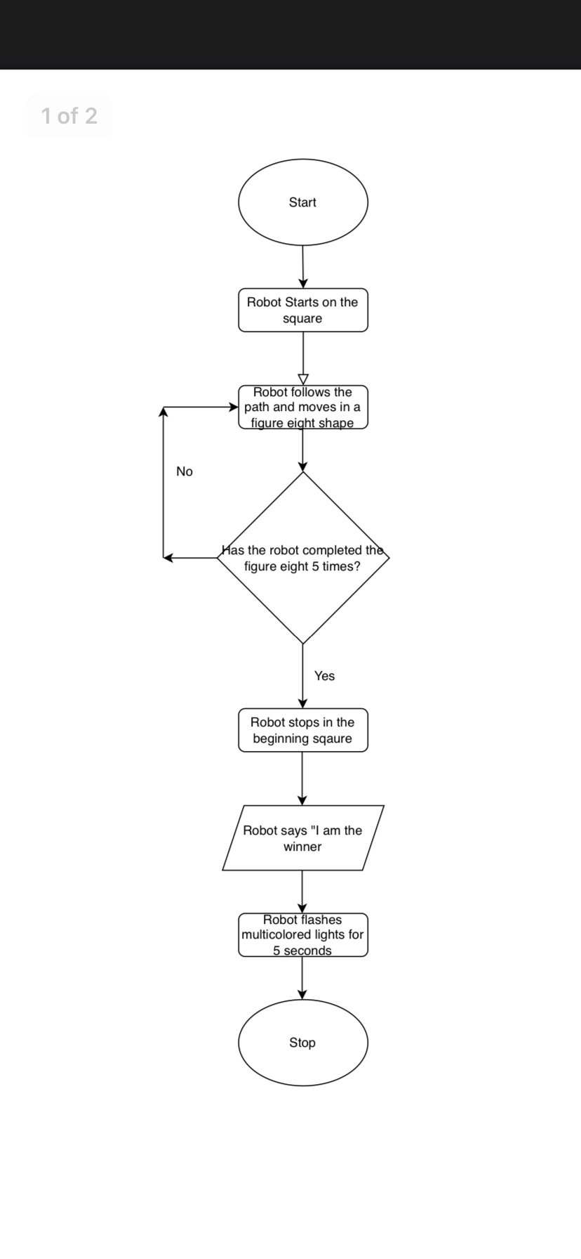

Software
We Used the Sphero Edu app to help us develop and use block code for our project. This app allowed us to make our algorithm into block code directly in the app like the picture below demonstrates.
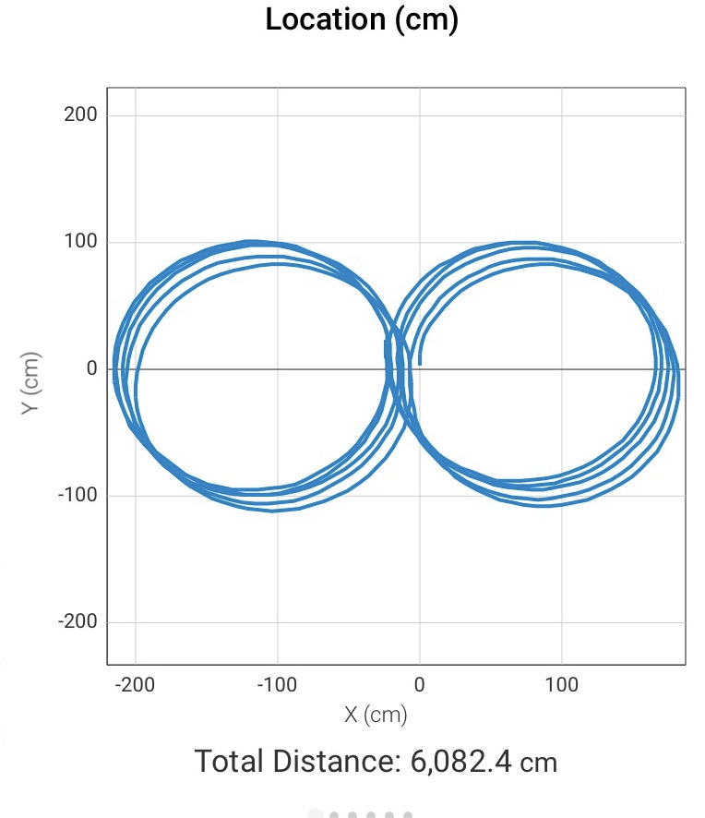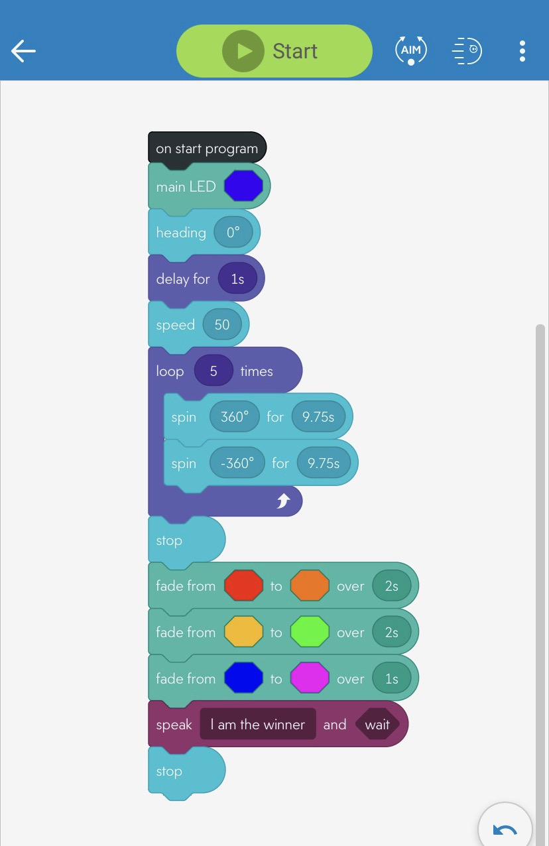

Hardware
The hardware we used for this project was the Sphero robot being the main device, and then iPhones, and laptops.
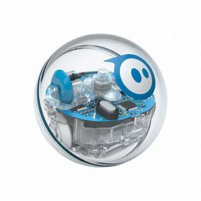

Test Plan
Include a test plan showing all unit tests performed for this application, Include test rational, test date, staff member, pass/fail status

Reason for Test Case | Test Date | Expected Output | Observed Output | Staff Name | Pass/Fail
To make sure the robot can perform its task | 11/17/21 | Robot will fail our first test of the block code | Robot could not follow the circle | Kevin, Jack, Jodan | Fail
To make sure the robot can perform its task by going around 5 times | 11/17/21 | Robot will go off track | Robot was almost perfect | Kevin, Jack, Jodan | Pass
To See if the robot can turn correctly | 11/17/21 | Robot will turn but stay straight | Robot went correctly but kept going for too long | Kevin, Jack, Jodan | Fail
To make sure the robot can perform its task | 11/17/21 | Robot will go straight and turn right but have a hard time flowing the blue tape | Robot went around the circle but just a little off the blue tape | Kevin, Jack, Jodan | Pass
To Make sure the robot can follow the course correctly so we can take a video | 11/17/21 | Robot will be almost perfect on following its task | The Robot did everything correct | Kevin, Jack, Jodan | Pass

Task List/Gantt Chart
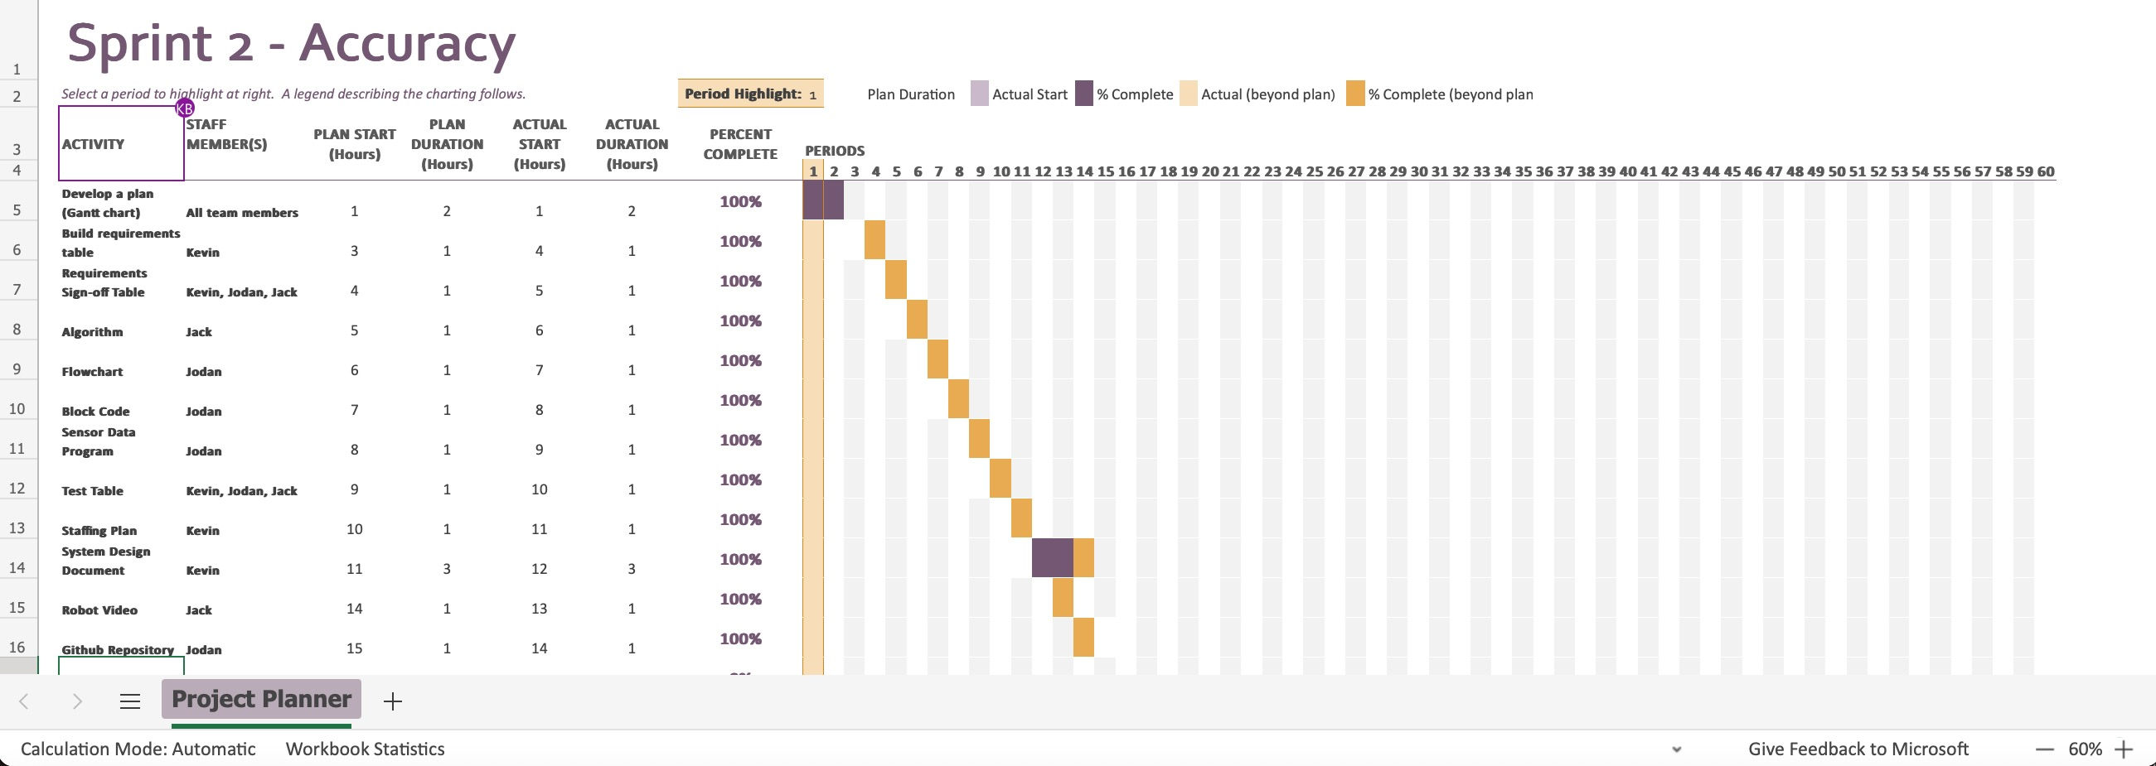

Staffing Plan
Insert a chart/table that depicts the roles and responsibilities of each team member that worked on this project

Name | Role | All Group members roles | Responsibility | Reports To
Kevin | SDD editor | Block code  Gantt chart  Sensor data diagram | To add information and edit the System Design Document while helping with Block code | All group members and professor
Jodan | Block code and Flowchart supervisor | Block code  Gantt chart  Sensor data diagram | To create a flow chart using draw.io following the algorithm. Recording the robot video while helping with Block code | All group members and professor
Jack | Algorithm/ Gantt Chart editor | Block code  Gantt chart  Sensor data diagram | To create a successful algorithm and overview the Gantt Chart while also helping develop block code | All group members and professor

